**CS 372 – Intro to Networks – Benjamin Brewster, adapted from Kurose & Ross**

Problems 4 – Chapter 4 (Book Required)

QUESTIONS

1. Open up [www.arin.net/whois in](http://www.arin.net/whois) a web browser.

a. Use the page to determine the IP address blocks for three different universities, and list them.

* Oregon State university: 209.206.253.184 - 209.206.253.191
* University of San Francisco: 63.204.215.144 - 63.204.215.151
* Texas University(Plano) : 68.76.71.72 - 68.76.71.79
* Washington University(Richmond) : 98.140.206.0 - 98.140.206.255

b. Can whois services be used to know where these universities are *exactly*, in terms of their geographical location, by using a specific IP address?

Yes the whois services give a city in which the ip address is located.

c. Use [www.iplocation.net to](http://www.iplocation.net/) try to find the locations of the web servers of these universities, and list your results.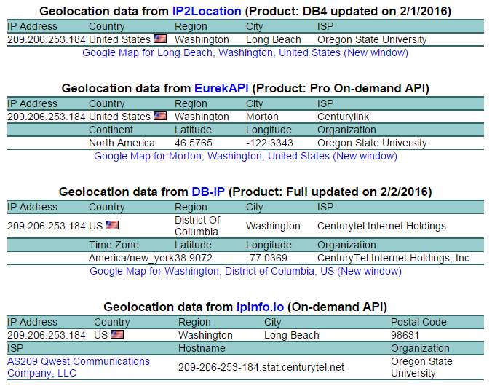



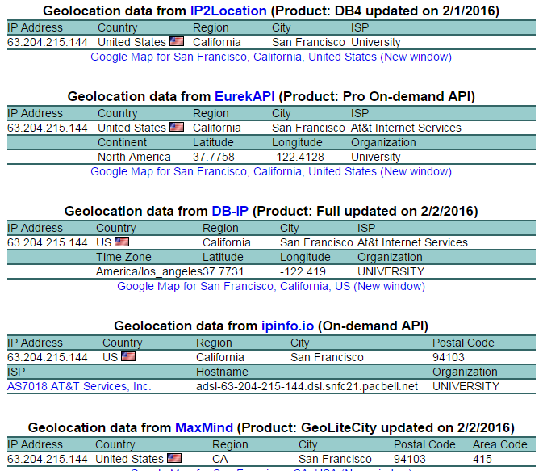

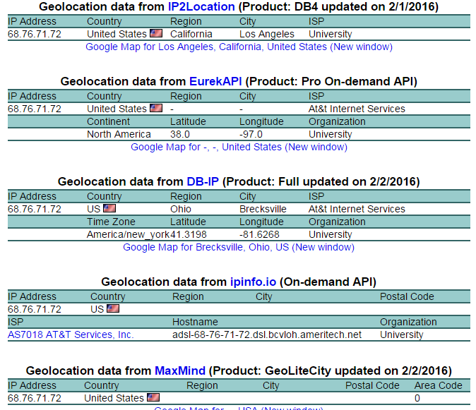

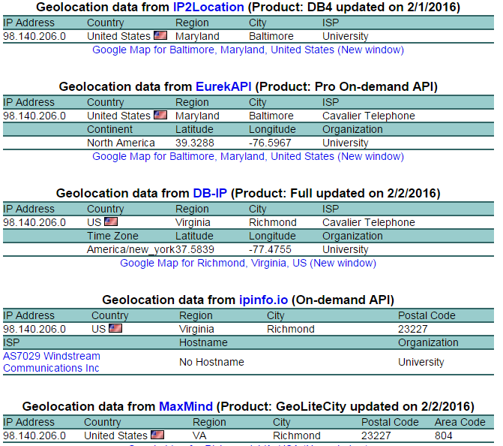

2. Examine the following network, with its routers named A-G and route costs as shown. Use Dijkstra’s Algorithm to compute the shortest path from router C to all other routers, building up a table with the same format as table 4.3 in your book, on page 368.

*Hint for self-check: at Step 5, N’ = CEFDBG:*

7

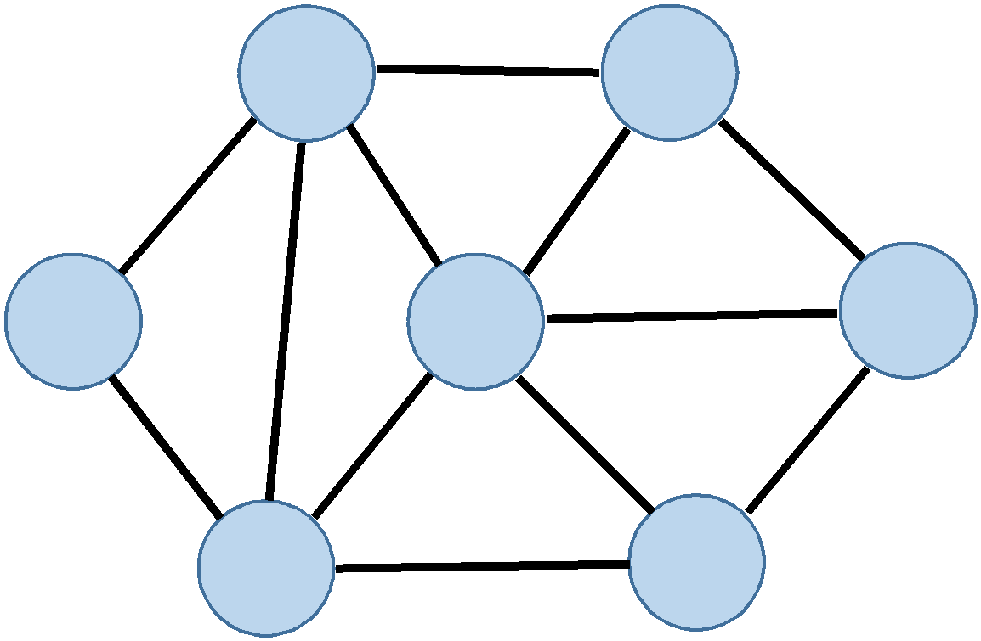

**B G**

12 8 4 2

3

**A** 6 **E F**

4

8 3 3

**C** 6 **D**

|  |  |  |  |  |  |  |  |
| --- | --- | --- | --- | --- | --- | --- | --- |
| Step | N’ | D(G), p(G) | D(F), p(F) | D(E), p(E) | D(D), p(D) | D(B), p(B) | D(A),p(A) |
| 0 | C | ∞ | ∞ | 3,C | 6,C | 6,C | 8,C |
| 1 | CE | 7,E | 6,E | - | 6,C | 6,C | 8,C |
| 2 | CEF | 7,E | - |  | 6,C | 6,C | 8,C |
| 3 | CEFD | 7,E |  |  | - | 6,C | 8,C |
| 4 | CEFDB | 7,E |  |  |  | - | 8,C |
| 5 | CEFDBG |  |  |  |  |  | 8,C |
| 6 | CEFDBGA |  |  |  |  |  | - |

3. Examine the network shown in Problem 2, above. Use the spanning tree algorithm given on

pages 403 and 404 to draw a tree rooted at A (that is, router A is the *core*) that includes as “leafs” (end nodes) routers B, E, D, and F (assume G is not in the network). Note that the link between two nodes chosen is always the smallest one, and selection is NOT based on looking more than one node ahead.

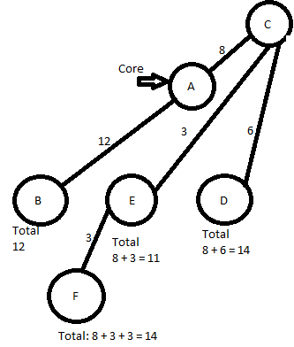

4. Is it true that routers have IP addresses? Discuss the number of IP addresses a router might have.

Ignore the multi-function “router” devices we use at home and work, and focus on the basic

router functionality we’ve discussed in class.

Yes routers do have IP addresses. The number of address is 255-2 so 253 since you have the network IP and broadcast IP. The network IP represents the 253IPs while the broadcast IP has all the data sent to all addresses. In other words all addresses from 000.000.000.001 – 255.255.255.254.

5. Let’s say we have a subnet with the prefix 128.119.40.128/26.

a. Give an example of any one IP address that can be assigned to this network.

1000000 01110111 00101000 10|000000

1000000 01110111 00101000 10|000001 = 128.119.40.129/26

b. Let’s further say that an ISP owns a block of addresses of the form 128.119.40.64/26. This ISP wants to create four separate subnets from this block, with each block having the same number of IP addresses. What are the prefixes, using form A.B.C.D/X for the four subnets?

1000000 01110111 00101000 00|000000 = 128.119.40.0

1000000 01110111 00101000 01|000000 = 128.119.40.64

1000000 01110111 00101000 10|000000 = 128.119.40.128

1000000 01110111 00101000 11|000000 = 128.119.40.192

6. In your own words, describe the terms **subnet**, **prefix**, **and BGP route**.

* **Subnet**: an identifiably separate part of a network
* **Prefix**: in networking prefix is the numbers before the more important number
* **BGP route:** an external protocol used to exchange routing information among AS on the internet.

7. Let’s say that two packets arrive at two separate input ports of a router at the exact same time.

Let’s further assume that the router is otherwise clear of packets. Answer the following three

questions:

1. If the two packets are forwarded to two separate output ports by the router, is it possible to forward them through the switch fabric at the same time if the fabric is using a shared bus?

No, you can only transmit one packet at a time using a shared bus.

1. If the two packets are forwarded to the same output port by the router, is it possible to forward them through the switch fabric at the same time if the fabric is using a crossbar?

No, in this case the two packets would have to use the same output bus at the same time, this isn’t possible.

1. If the two packets are forwarded to two separate output ports by the router, is it possible to forward them through the switch fabric at the same time if the fabric is using a crossbar?

Yes, as long as the two packets use different input buses and different output buses, they can be forwarded in parallel.

8. Can loops be detected in routing paths by BGP? Is possible, describe how. If not possible, describe why not.

Depends on internal or external BGP.

Yes, using AS_PATH attribute as a route crosses between autonomous systems, the AS number of the transmitting router is added to the AS_PATH attribute. If a router sees its own AS number in that path list, then it considers it to be a routing loop and ignores it.

9. Convert the IP address 223.1.3.27 to its 32-bit binary equivalent.

1101111 00000001 00000011 00011011

10. Let’s say that datagrams are limited to only 1.5 kilobits, which includes the header. Assuming a

20-byte IP header, and a 20-byte TCP header, how many datagrams would be required to download a 5 million byte image file? Make sure you show your work.

1.5 kilobits = 1.5 * 103 = 1500 bits / 8 = 187.5 bytes

Head size is 40 bytes

File size = 5,000,000

Total size after subtracting header is 187 – 40 = 147 per datagram rounded up is 147.

File size / 147 = 34013.61 datagrams rounded up is 34014.

11. We’ve discussed three different types of switching fabrics in section. In your own words, and describe each of these methods. Can any of these send multiple packets across the switching fabric at the same time (that is, in parallel)?

* Memory: yes can be but is limited by memory and bus speeds
* Bus: No cannot be done in parallel
* Interconnection network (Crossbar): Can be if input and output buses are unique for each packet.

12. Imagine that you are trying to download the image file described in problem 10, and that your computer is behind a router that is using Network Address Translation (NAT) – i.e., packets sent from your computer will have their address translated to something else when they go through and out of your router to the internet. If the server you are trying to download the file from is *also* behind a NAT, can your computer establish a TCP connection to the server, assuming that your download application hasn’t been specifically programmed to work with either or both NATs? Why or why not?

Yes, because the server will receive the request to download the file then send a request to establish a TCP connection with my computer or vice versa. It doesn’t matter if the application isn’t programmed for it as we can use connection relays to work around it.

INSTRUCTIONS

Write up your answers in any way you see fit, including appropriate equations and descriptions. Submit the resulting work as a document upload to Canvas, either scanning your paper work, or producing the work initially on a computer. If you have multiple files, please enclose them in a zip file.

I recommend you work in groups. If you choose to do so, you must still write and turn in your own work. Please post your questions onto the relevant Canvas Discussion board.

GRADING

Each problem is worth 10 points if correctly answered, and worked out with appropriate equations and descriptions. If an answer to a problem is only partially correct, or is grossly missing supporting work, the grader may instead assign 5 points. Completely wrong or unanswered problems are worth 0 points. The total available is 120 points for this assignment.